PROJECT TITLE:

microgoal

TEAM DETAILS:

TEAM ID: NM2025TMID40084
TEAM MEMBERS:
TEAM LEADER: HARINI S
NM ID: 7B5FBDF14C60BA0B18E4C0F97C566B84

TEAM MEMBER: JAYA SRI R
NM ID: 46FA5ABC4F59736812C46F90B9A0A125

TEAM MEMBER: SANDHIYA M
NM ID: 88F43933E420CCA9A7849156A8769EA1

TEAM MEMBER: HARINI S
NM ID: CB5B2C4BAC94036817C4D076E70126E5

OBJECTIVE:
- Break down complexity → Instead of tackling a huge backend project at once, microgoals split it into small, clear tasks.
- Focus on clarity → Each microgoal has a specific purpose (like “create user table” or “implement login API”), so you know exactly what to achieve.
- Measure progress → Since microgoals are small, you can easily track completion and see steady improvement.
- Boost confidence → Finishing small goals gives motivation and builds confidence to handle bigger tasks.
- Skill building → Each microgoal targets a particular backend skill (database, authentication, security, performance), so you gradually master all areas.
- Team efficiency → In group projects, microgoals help divide work clearly among team members.
In short: Objective of microgoal = make learning and development structured, achievable, and motivating.
PLATFORM AND TECHNOLOGY USED
1.Platform Used
The Microgoal project is developed as a backend application using Node.js. Visual Studio Code (VS Code) is used as the development platform to write and manage the server-side code. The project runs on a Node.js environment and uses MongoDB Atlas as the cloud database to store user data and goal information. The application is tested and executed on a Windows operating system.
Backend Technologies
The backend of the Microgoal project is developed using Node.js and Express.js. Node.js is used to run JavaScript on the server side and handle application logic. Express.js is a web framework used with Node.js to create APIs and manage HTTP requests and responses. It helps in building a structured and scalable backend application.
3.Database
MongoDB is used as the database for this project. It is a NoSQL database that stores data in a flexible JSON-like format. MongoDB Atlas is used as a cloud-based database service that allows the application to store and retrieve data easily. Mongoose is used as an Object Data Modeling (ODM) library to interact with MongoDB and manage database schemas.
4.API Development
RESTful APIs are created in this project to manage micro goals. These APIs allow users to perform operations such as creating a goal, updating a goal, deleting a goal, and viewing goal progress. The APIs connect the server with the database and ensure smooth data communication.
5.Tools Used
Several tools are used during development. Visual Studio Code is used for coding, Postman is used for testing APIs, and npm (Node Package Manager) is used to install and manage project dependencies.
Conclusion
The Microgoal backend project is developed using modern server-side technologies such as Node.js, Express.js, and MongoDB. These technologies help to create a reliable, scalable, and efficient backend system for managing and tracking user goals.
IMPLEMENTATION/PROCESS
1. Environment Setup
First, the development environment is prepared by installing Node.js and Visual Studio Code. A new project folder is created and the required packages are installed using npm. This setup helps to start the backend development process.
2. Server Creation
Next, the server is created using Express.js. Express helps to build the backend application and handle HTTP requests from the client. The server runs on a specific port and waits for incoming requests.
3. Database Connection
After creating the server, the application is connected to MongoDB Atlas. MongoDB Atlas is a cloud-based database used to store goal information. Mongoose is used to connect Node.js with MongoDB and to define the structure of the data.
4. Creating API Endpoints
RESTful APIs are created to manage micro goals. These APIs allow users to perform different operations such as creating a new goal, viewing goals, updating goal details, and deleting goals.
5. Testing the APIs
Postman is used to test the API endpoints. Each API request is checked to ensure that the server responds correctly and the data is stored or retrieved from the database properly.
6. Error Handling
Error handling is implemented in the backend to manage problems such as invalid requests or database connection issues. This helps the application run smoothly.
7. Testing and Deployment
- The application was tested locally in Visual Studio Code
(VS Code) using the Vite development server
(localhost:5173).
- Debugging was carried out to fix styling issues, broken
links, and functionality errors.
The final project was committed and pushed to GitHub
for version control and future hosting.
- Finally, the whole backend system is tested to make sure that all features work properly. The application ensures that users can create, update, view, and delete their micro goals successfully.
8. Deployment and Execution
After completing the development, the backend server is executed using Node.js. The server starts running on a specific port and becomes ready to handle client requests. The APIs interact with the MongoDB database to store and retrieve micro goal data. This step ensures that the backend application works properly and performs all operations successfully.

PROJECT ARCHITECTURE
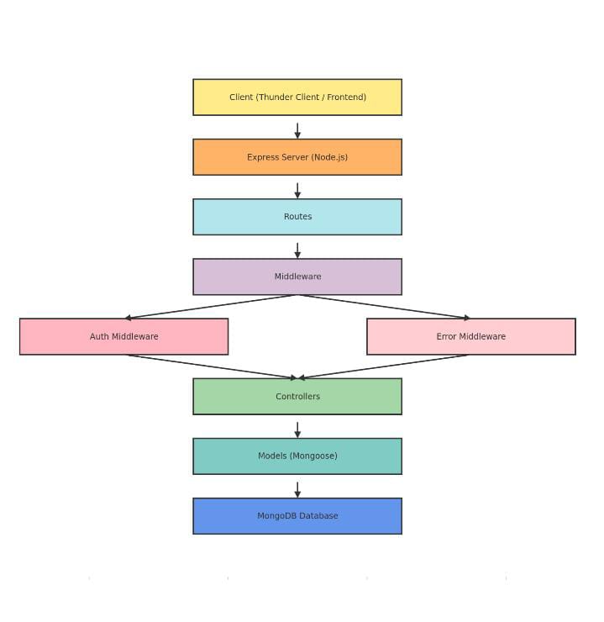

TECHNICAL ARCHITECTTECHNICAL ARCHITECTURE

Runtime: Node.js

Framework: Express.js

Database: MongoDB

Authentication: OWT

Architecture Pattern: MUCURE

FEATURES

- User Registration
- Secure Login with OWT
- Create Goal
- Update Goal
- Delete Goal
- View User-specific Goals
- Protected Routes
- Centralized Error Handling

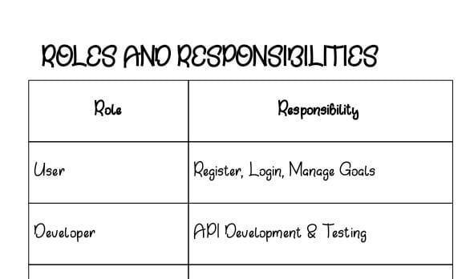

USERS FLOW
1. User registers
2. User Logs in
3. OWT token generated
4. User sends token in header
5. Access protected routes
6. Perform CRUD operations
OUTPUT
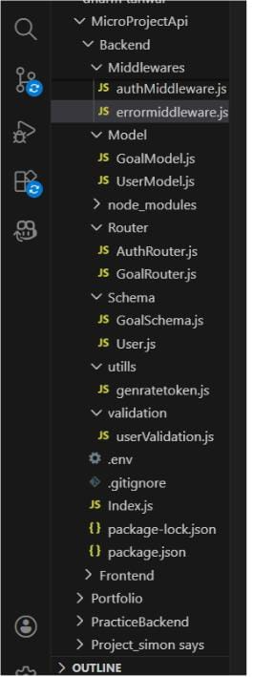

- Successful User Registration (Signup/Login)
- In this Api call the user register or login and token was generated.
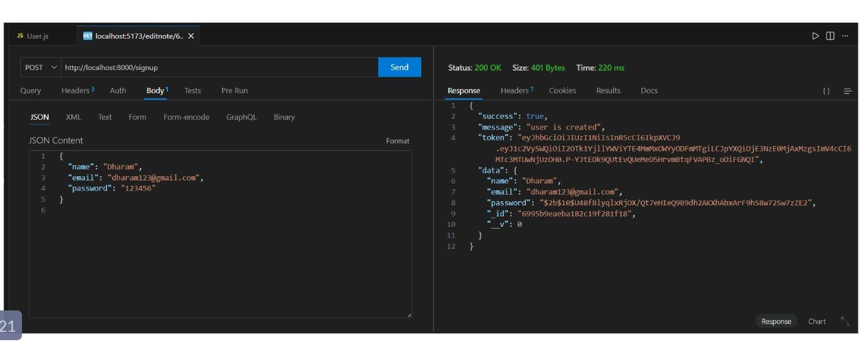
- JWT Token Response

After successful login user the api generate the token and these token was sent with every request to every api.
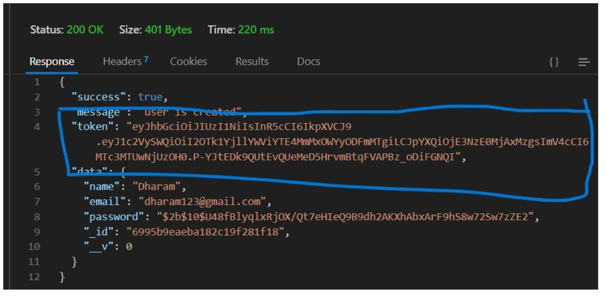
- Goal Created Successfully.

- After the login and token is generated the user give post request to api for creating there goals and goal was save in MongoDB which was the database

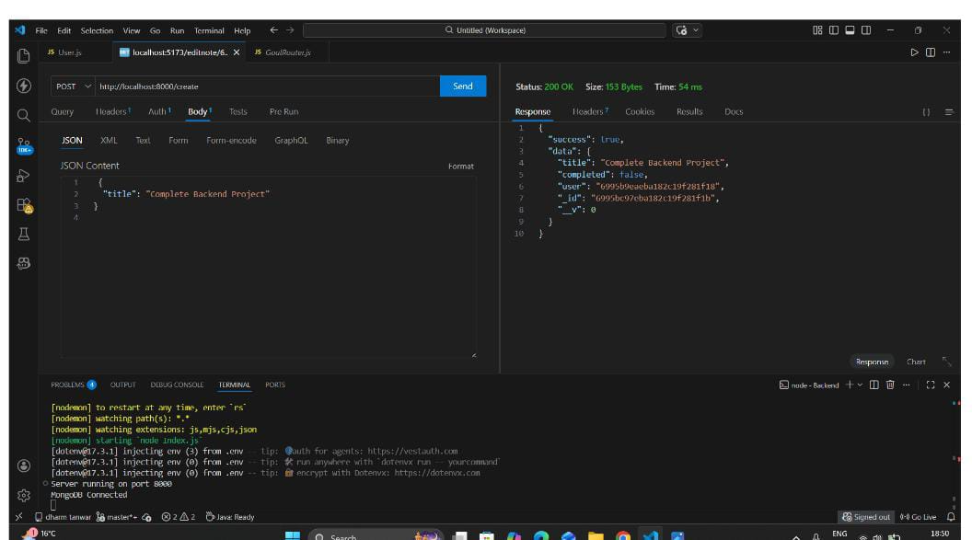

- Protected Route Working
- If the user does not have token which was generated by backend api then he cannot access the api so Route are protected

Github:
https://github.com/harini-rythmic/microgoal.git
Demo video:
https://drive.google.com/file/d/1raPQvSnhOLkTuaKId95InFjJUTKhB8fO/view?usp=sharing

